# Country Specific Guideline for Chile

This guideline has been prepared by the Australian Government and the Government of Chile. It is intended to assist businesses importing regulated timber products from Chile into Australia in understanding the regulatory framework in Chile in order for them to carry out their due diligence obligations under the *Illegal Logging Prohibition Regulation 2012*, which supports the *Illegal Logging Prohibition Act 2012*.

This guideline was co-endorsed by the Australian and Chilean governments on 19 February 2020.

Contents

Country Specific Guideline for Chile 1

1 What is required under Australia’s Illegal Logging Laws? 3

2 How to use the Country Specific Guideline (CSG) 3

3 Scope of the CSG for Chile 4

3.1 Timber harvested outside of Chile 4

4 Overview of forest management in Chile 5

4.1 Forest ownership 5

4.2 Agencies responsible for managing and regulating forests 6

4.3 Bans or limitations on harvest of specific species 7

5 Timber products exported from Chile to Australia 9

6 Laws and regulations governing forestry in Chile 9

6.1 Domestic timber harvesting 10

6.2 Timber transportation and exportation 14

7 Identifying legal product from Chile 17

7.1 Timber Legality Frameworks 17

8 Who should I contact for further information 19

Annex 1: Native Forest Products Transit Chart 20

Annex 2: Single Export Document - *Documento Único de Salida – Aceptación a Trámite- DUS–AT (Sample)* 21

21

Annex 3: Free Transit Guide- *guías de libre tránsito (Sample)* 22

22

## What is required under Australia’s Illegal Logging Laws?

Australia’s *Illegal Logging Prohibition Regulation 2012* (the Regulation) prescribes due diligence for businesses importing ‘regulated timber products’ and for Australian processors of domestic raw logs. Under the Regulation, importers and processors have to undertake due diligence to minimise the risk of sourcing illegally logged timber.

The due diligence requirements for importers include the following steps:

**Step 1:** Establish and maintain a due diligence system.

**Step 2:** Gather information about the timber in the product that is being imported

**Step 3:** Assess the risk (using one of the three methods outlined in the Regulation)

**Step 4:** Risk mitigation (if required)

**Step 5:** Keep records

Further information about the Regulation and the due diligence requirements is available at the Australian Government Department of Agriculture, Water and the Environment’s website ([www.agriculture.gov.au/illegallogging)](http://www.agriculture.gov.au/illegallogging)).

## How to use the Country Specific Guideline (CSG)

This CSG is intended to assist an importer of regulated timber products from Chile to Australia to comply with the Regulation’s due diligence requirements.

In accordance with section 10 of the Regulation, an importer must gather information about the product they are seeking to import, this includes gathering the information or evidence described in this CSG.

The information listed in this CSG is not meant to be an exhaustive list of evidence or documentation required to satisfy the due diligence requirements under the Regulation.

The information gathered by applying this CSG, along with any other information gathered in accordance with the Regulation, needs to be assessed in accordance with the processes outlined in section 12 of the Regulation. This includes giving consideration to any other information the importer knows, or ought reasonably to know, but is not contained in the CSG.

All data included in this document is the most current as available at time of publishing.

## Scope of the CSG for Chile

This CSG provides detailed information on the control of pathways for timber harvested and originating from within Chile and informs Australian importers of what is considered legal timber according to Chilean law. It is only applicable for timber products with a Chilean origin of harvest.

### Timber harvested outside of Chile

There may be timber, forest products or products which contain timber, wholly or in-part that was harvested in another country, before it was imported to Chile. These products do not fall within the scope of this CSG.

However, information contained in this document may assist importers in conducting their due diligence on such products through one of the other risk assessment pathways available under the Regulation.

## Overview of forest management in Chile

Chile has 17.9 million of hectares covered by forests[1]. This includes 14.6 million hectares of native forests, 3.1 million hectares of forestry plantations, and 0.18 million hectares of mixed woodlands.

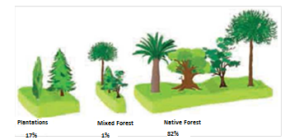Native forests

A native forest is defined in Chilean law[2] as "*a forest composed of native or autochthonous species, coming from natural regeneration or under canopy plantation, with the same species present in the original distribution area, that could have an adventitious presence of randomly distributed exotic species.*" Native or autochthonous (i.e. indigenous) species are established by supreme decree.[3]

The main commercial timber species found in Chile’s native forests include Lenga (*Nothofagus pumilio*), Roble (*Nothofagus oblicua*), Tineo (*Weinmannia trichosperma*) and Rauli (*Nothofagus alpina*).

Approximately 3.7 out of the total 14.6 million hectares of Chile’s native forests are protected in state nature reservations.

Plantation forests:

Chile has 3.1 million hectares of forestry plantations. Approximately 57.6% of this area is made up of radiata pine, with 35.6% from the eucalyptus genus. Other major genus’ and species include atriplex, tamarugo and Douglas fir (*pino oregón* in Chile). Plantations provide 99.6% of Chile’s industrial timber supply.[4]

### Forest ownership

The state holds close to 22% of all native forest tenure, while the rest is in the hands of producers of various sizes.[5]

Approximately 20 percent of Chile’s forest estate is included inside the State’s National System of Protected Wild Areas (SNASPE – Spanish acronym). The System was created by law to govern any activity that takes place in a protected wild area of the State[6]; namely parks, reserves, and natural monuments. It currently has 101 units, distributed across 36 National Parks, 49 National Reserves and 16 Natural Monuments. Further information on the restrictions placed on timber harvesting in these areas is included on page **12**.

The majority of plantation forests are owned by private companies; 60% of the Chilean plantation estate is held by three big companies, with the remaining estate owned by more than 20,000 small and medium-sized producers.

#### Indigenous ownership

A series of indigenous land protection standards have been established[7] which prevent the disposal and seizure of indigenous lands, impose a levy on the use of these lands without authorization from the National Corporation for Indigenous Development (CONADI - Spanish acronym), and prevent parties from taking adverse possession of those lands, except when occurring between communities or indigenous peoples of the same ethnic group.

Chile has also ratified the Convention on Biological Diversity (CBD), which protects *in situ*–*ex situ* plant species and their sustainable use through environmental education and participation of local communities. The convention was enacted into domestic law in 1995 through Decree No. 1963 of the Ministry of Foreign Affairs.

### Agencies responsible for managing and regulating forests

There are a number of agencies with responsibility and interest in forest management in Chile.

The **Ministry of Agriculture** is the institution of the State charged with promoting, guiding and coordinating forestry and agriculture activity in Chile. Two agencies attached to the Ministry are fully dedicated to the forestry sector, as described below:

* **The** [**National Forestry Corporation**](http://www.conaf.cl/) **(Corporación Nacional Forestal - CONAF)** has the mission of contributing to the sustainable management of native forests and forest plantations. It does this through the functions of development, control of forestry-environmental legislation and protection of vegetation resources, as well as the conservation of biological diversity through the National System of Protected Wild Areas, for the benefit of society. Laws and regulations allow CONAF to regulate and control forestry activities. To regulate the intervention and exploitation of forest species, CONAF applies a set of actions to enforce legal and technical standards regarding the utilisation, conservation, and protection of forest resources and the environment.
* **The** [**Forestry Institute**](https://www.infor.cl/) **(INFOR)** is Chile’s technological forest research institute. It has a mission of "*Creating and transferring scientific and technological knowledge for the sustainable use of forest resources and ecosystems, product development and associated services, as well as generating relevant information to the forestry sector in the economic, social and environmental aspects*".

Other relevant institutions include:

* **The National Customs Service** is an autonomous public entity, which sits within the Ministry of Finance. The National Customs Service monitors and controls the movement of goods, along the coasts, borders and airports of the Republic; intervenes in international border operations to collect import, export and other taxes determined by law; and generates border traffic statistics, without prejudice of other duties provided by law.
* **The Public Prosecutor’s Office** is a constitutionally autonomous agency whose role is to lead the investigation of facts that constitute a crime, to file those cases with independent jurisdictional penal courts.

### Bans or limitations on harvest of specific species

#### Protected species

Some species have special protection status under Chilean law. Chilean Larch (*Fitzroya cupressoides*) and Chilean pine (*Araucaria araucana*) have been declared as natural monuments by Supreme Decrees.[8] Logging of these trees is prohibited throughout the domestic territory, unless expressly authorized by CONAF for specific purposes including: duly authorized scientific research, public construction works, national defence works, or for the achievement of Forestry Management Plans by official State institutions (whose exclusive objective is to preserve and improve the species).

Queule (*Gomortega keule*), Pitao (*Pitavia punctate*), Belloto de Sur (*Beilschmiedia berteroana*), Belloto del Norte (*Beilschmiedia miersii*), and Ruil (*Nothofagus alessandrii*) also have special protection status under Decree No. 13 of 1995 banning their logging and destruction, unless expressly authorized, qualified, and justified by CONAF.

In the case of Chilean Larch, the harvest of dead specimens is allowed with prior authorization of a ‘dead wood extraction management plan’ issued by CONAF. However, the commercialisation of those products is only possible domestically because this species is included in Appendix I of *Convention on International Trade in Endangered Species of Wild Fauna and Flora* (CITES). Therefore, products comprising of Chilean Larch cannot be imported into Australia. Chilean Larch deadwood products carry a unique identifier from every producer and are physically stamped using a hammer.

#### CITES

CITES was enacted into Chilean Law in 2016. Law No. 20.962 legislates for the prevention, control and sanction of conduct in contravention of the CITES.

Chile bans and/or restricts the harvest or collection of flora and fauna species listed in accordance with the [CITES Appendices](https://www.cites.org/eng/app/appendices.php), including those declared as natural monuments. All trade in CITES listed species (e.g. *Araucaria araucana, Pilgerodendron uviferum*) is strictly regulated and must be accompanied by the appropriate documentation where trade is permissible. All cross-border trade of CITES-listed species needs to be documented and accompanied by required export, import and re-export certificates issued by CONAF.

By exception, specimens of these categories may be exported or imported for scientific purposes through prior authorization from CONAF and with the issuance of a CITES Export Permit. If those requirements are not fulfilled, it may be considered smuggling. Offences provided for under Article 169 of the Customs Law may also be applied if false data is provided during the submission of the documentation. The common offence provided for under Article 168(2) of the Customs Law, doctrinally known as the ‘Crime of Smuggling’, punishes the entry into, or exit from, the national territory of any good to which imports or exports are prohibited.

Law 20.962 also punishes administrative and criminal offences. Possession and holding of forbidden species are punished administratively with a fine, and such interventions are sanctioned by the Local Police Court. Criminal offences punished as a special kind of counterfeit crime are investigated by the Public Prosecutor´s Office, and are settled in a jurisdictional criminal court.

#### Protected Areas

There are also areas within Chile where logging is restricted, for more information on these restrictions see Section 6.1 – Domestic Timber Harvesting.

## Timber products exported from Chile to Australia

In 2018, Chile was Australia’s 15th highest source (by value) of regulated timber products with a total of A$108 million in imported products. Major products are detailed in Table 1.

Table 1 - List of major regulated timber products exported to Australia by value (2018)

|  |  |  |
| --- | --- | --- |
| **Products** | **HS Codes** | **Value** |
| Continuously shaped wood, coniferous | 4409 | A$ 28.5 million |
| Plywood or laminated wood, or veneered panels | 4412 | A$ 22.4 million |
| Sawnwood | 4407 | A$ 21.1 million |
| Chemical wood pulp, soda or sulphate, semi-bleached or bleached | 4703 | A$ 17.9 million |
| Coated paper and paperboard | 4810 | A$ 11.1 million |

**Source**: Australian Government Department of Agriculture, Water and the Environment, 2019

## Laws and regulations governing forestry in Chile

Chile has a robust forest institutional framework. There are several main legal instruments that regulate forestry in Chile:

1. Decree Law No. 701 of 1974 on Forest Development
   * Regulates activities on lands preferentially suitable for forestry and degraded lands and encourages forestation. Gives CONAF and its officials express law enforcement powers.
2. Law No. 20.283 of 2008 on Recovery of Native Forest and Forest Development (often referred to as *Native Forest Law*)
   * Provides incentives to various stakeholders including small forest owners to establish native trees. It aims to protect, recover and improve native forests.
3. The Forest Act No. 4.363 of 1931 of the Ministry of Territories and Colonization
   * Regulates logging in general terms.
   * Provides a mandate to protect forests, and provides powers to establish national parks and reserves.
4. Law No. 19.300 of 1994 on General Bases of the Environment
   * Aims to protect native forests, and provides requirements for environmental impact assessment systems.

These legal instruments set out the requirements that must be met to manage Chile’s forests (including any silvicultural activities), and establish sanctions for those who do not comply with the laws and regulations. Regulations are part of the legal framework enforced by CONAF as the technical administrative authority. Depending on the law, an administrative authority enforces it through fines or other administrative measures; including stages where the courts of justice will resolve any enforcement actions.

### Domestic timber harvesting

Forest harvesting activities must be pre-authorised by CONAF. To harvest or manage most Chilean forests[9], a producer must submit a forest management plan (i.e. the applicable native forest management plan or plantation management plan) and pay a tax that corresponds to the area to be harvested/managed.

Native Forests:

* All harvesting of native forest on any terrain is required to have a native forest management plan approved by CONAF under Act 20.283 of 2008 on native forests.
* Additionally, where the native forest management plan involves circumstances covered by Act 19.300 and its associated regulations, an Environment Impact Assessment/Statement approved by the Ministry of the Environment (*Ministerio de Medio Ambiente*) is required, otherwise clearcutting or conversion is not permitted. Relevant circumstances include forestry development or exploitation projects on fragile soils, or in native forests where endangered species are present. This will result in a sectorial permit (or Management Plan of Civil Works) which must be submitted to CONAF.

Where an Environment Impact Assessment/Statement is required, importers can potentially check its status by using the following link: <http://seia.sea.gob.cl/busqueda/buscarProyecto.php> (although the site is in Spanish). All the official information is contained in the project dossier.

* All timber produced and commercialised must have a ‘free transit guide’ (*guías de libre tránsito*). These certificates have a limited period of validity, after which the product becomes illegal and cannot be further processed, even if it is in or has come from a place that holds a native forest management plan. An example of a ‘free transit guide’ can be found in Annex 3.

In the above circumstances, where there is an approved forest management plan this is considered to be the equivalent of an approved harvesting permit. Aforest management plan provides information including the surface area to be managed and/or felled, forest/plot parameters, environmental specifications regarding protected areas or elements, practices for pest control and fire prevention.

Plantations:

* There is an obligation for forest plantations on lands preferentially suitable for forestry[10] to have a management plan presented (regardless of whether it is on state or privately-owned land) and approved by CONAF, prior to any harvesting activity taking place.
* There is no obligation for owners of forest plantations on land not defined as preferentially suitable for forestry (e.g. on agricultural lands) to have a plantation management plan, and forest owners/managers do not require harvest approval from CONAF.

Tables 2 and 3 set out the management, types of timber sourced, and whether a forest management plan is required for both native forests and plantations respectively.

Table 2: Private and State owned Native Forests

|  |  |
| --- | --- |
| **Native Forests** | |
| *Privately-owned productive forests* | |
| Management Aim | * Conservation and productive management. * Development incentives are offered to manage commercial or conservation forests under Act 20.283. |
| Timber Sourced | * Logs and sawnwood from native species, except those declared as a natural monument or endangered. |
| Harvesting permit type | * CONAF-approved native forest management plan |
| Transport permit | * Timber resource extraction can only be done with a free transit guide, or transit note issued by CONAF following approval of the management plan. |
| *State-owned forests* | |
| Management Aim | * Multiple-use purpose. |
| Timber Sourced | * Logs and sawnwood from native species. |
| Harvesting permit type | * CONAF-approved native forest management plan. |
| Transport permit | * Extracting timber resources can only be done with a free transit guide (or transit note) issued by CONAF following approval of the management plan. |
| *State-owned national parks, forest reserves and natural monuments* | |
| Management Aim | * Preservation and conservation. * Removal of species declared as natural monuments is forbidden. * On reserves, existing forest management can be done provided it is not detrimental to forest attributes. Some reserves have forest plantations open to public tender so that private companies can commercialise them. |
| Timber Sourced | * Protected forest. These forests provide for nature tourism and biodiversity protection. * By exception, with the respective management plan, logs or sawnwood can be removed from reserves in small quantities. |
| Harvesting permit type | * CONAF-approved native forest management plan |
| Transport permit | * Extracting timber resources can only be done with a free transit guide (or transit note) issued by CONAF following approval of the management plan. |

Table 3: Private Plantations

|  |  |
| --- | --- |
| **Plantations** | |
| *Private exotic plantations (3.1 million hectares)* | |
| Management Aim | * Productive management and conservation in areas which have been declared protected sites. |
| Timber Sourced | * Exotic timber plantations. Logs for pulpwood and sawn-wood, mainly pine and eucalyptus. * Non-timber forest products removal by harvesters who have contracts with logging companies. |
| Harvesting permit type | * **Land preferentially suitable for forestry:** For felling of any plantation there must be a CONAF-approved **plantation management plan**. * **Land not preferentially suitable for forestry**: A plantation management plan is not available; instead documents such as delivery orders, invoices, or forest management certification should be sought. |
| Transport permit | * Transport permits are not required for timber resources obtained from forest plantations. |

#### Harvesting restrictions

Timber harvesting in national parks and natural monuments is prohibited. Harvesting is only permitted in national reserves under certain restrictions, and where prior authorisation (through a forest management plan) has been obtained from CONAF. Harvesting on fragile soils, high slopes, glaciers or in close proximity to streams is restricted. The specific requirements are stated in the corresponding laws and regulations; the requirements depend largely on the specific terrain conditions and/or the type of forest to be harvested (i.e. native or plantation).

#### Compliance Monitoring and Enforcement

As part of undertaking forest inspections, CONAF undertakes two main activities: detecting illegal logging; and assessing compliance with management plans. Figure 1 below summarises the forest inspection process performed by CONAF in accordance with the main legal instruments that regulate forestry activities.

Figure 1: Chart summarising the forest inspection process performed by CONAF

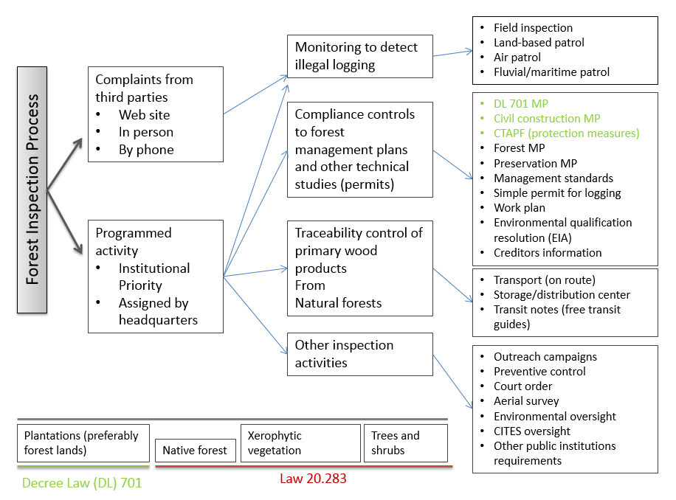

When harvesting is performed without an approved forest management plan (where mandatory), or is conducted in contravention of the specifications included in its authorisation (e.g. different areas or species are harvested, or higher volumes are extracted), this will be deemed an ‘unauthorized cutting’ or illegal logging activity by CONAF.

* **Unauthorized cuttings** are sanctioned with a penalty fee equivalent to twice the commercial value of product obtained. However this will increase proportionally if such goods have been removed from the field and are no longer traceable. Where a protected species is harvested, a penalty is applied for each harvested tree.
* Although CONAF performs inspection and quantification of **illegal logging activities**, the penalties for such interventions are sanctioned by the Local Police Court.

Under what is known as the ‘*Illegal Logging Crime’*[11]*,* Article 21 sets out penalties for where it is determined that trees and/or shrubs have been cut or destroyed in non-compliance with the specifications set out in Article 5 of the same law. These specifications include:

1. Native trees and shrubs located less than 400 meters above springs born in the hills and those located less than 200 meters from its banks (from the point where the slope originates to that in which the plan ends).
2. Trees less than 200 meters from springs born on flat non-irrigated land.
3. Native trees and shrubs on slopes above 45%.

With the notable exception being where there are justifiable reasons and prior approval of a Forest Management Plan in accordance with Decree Law No. 701 of 1974.

The *‘Illegal Logging Crime’* is prosecuted by the Public Prosecutor’s Office, who is in charge of the criminal investigations in Chile, and settled in a jurisdictional penal Court. This crime can be punishable with penalties of between 61 to 540 days of imprisonment and a fine of approximately 430,000 CLP to 860,000 CLP (approximately A$900 to A$1800).

In those situations where illegally harvested timber has been confiscated by the Chilean Government and then later publicly auctioned, the following documentation can be used to demonstrate the legitimate nature of the timber:

* a Criminal Judge´s ruling, establishing the confiscation sanction; and
* a Ruling/resolution, establishing the public auction of said timber.

### Timber transportation and exportation

#### Transporting timber

Forest products that are being transported must clearly specify key information including their origin, volume or weight, type and transaction unit.

Native forest

The transportation of ‘primary products’ from native forest (defined below) require a **Free Transit Guide** (guías de libre tránsito - a transit note) issued by CONAF; this proves the legal origin of the wood.[12] Demonstration of the legal origin of primary products is mandatory for their transportation, using Free Transit Guides, in any stage of the utilisation process of native forest primary products (these are defined in Figure 2). It is illegal if the quantities, species and/or origins are not correctly declared. Free Transit Guides can be required by both CONAF inspectors and National Police officers.

A transit chart detailing the pathway of native forest products is included at Annex 1.

Figure 2: Definition of Primary Products from Native Forest

***Primary Products from a Native Forest***

A Primary Product from a Native Forest is a product directly obtained from existing native forest species growing under a natural condition, or that are the result of a first processing. The following are the main native forest wood products:

* Pulp logs and sawing logs
* Wood posts, stakes, guides, and cords
* Wood chips with or without bark
* Sawn timber (foundations, boards, planks, covers or linings, semi-cylinders, roof shingles, and floorboards)
* Firewood
* Manufactured or sawn railroad ties.

Plantations

Plantation harvested timber is not accompanied with a Free Transit Guide; these are not issued for products harvested from plantations.

#### Exporting timber

In relation to documents and requirements which are mandatory for export, these are specified in the Compendium of Customs Regulations.[13]

Control of primary products, prior to exportation, is conducted using a three-step risk analysis:

1. Physical inspection
2. Documentary inspection
3. Specimen identification, and its incorporation, if applies, in one of the CITES appendices.

Customs have adopted as an internal oversight measure the ability to request (when goods are declared to customs) Free Transit Guides. This helps them to verify the primary native forest products come from a logging activity authorised by CONAF in accordance with established laws.[14]

Exporters must also submit to the National Customs Service, via a customs broker, the Single Export Document - acceptance for processing (*Documento Único de Salida – Aceptación a Trámite- DUS–AT*), which must contain all the information required.[15] An example of the DUS-AT is included at Annex 2.

In addition to the DUS–AT, the mandate given to the customs brokers must be submitted, together with the shipping note or instructions, the transport and freight documents, a copy of the commercial invoice issued, as well as the necessary signatures and/or authorizations, which are specified in the Annex 40 of the Compendium. For the case of goods whose ‘Free on Board’ (F.O.B.) value does not exceed US$2,000, they can apply a simplified procedure.

#### Export restrictions

In conformity with domestic legislation or international agreements, Chile prohibits or controls the export of certain products. In addition to CITES listed species (described in greater detail in Section 4.3 of this guideline), other prohibited exports include anthropological, archaeological, ethnic, historical and paleontological items and articles.

Documents and requirements, which are mandatory for export operations, are specified in Customs regulation corresponding to the Compendium of Customs Regulations.[16]

## Identifying legal product from Chile

Australian importers of wood and wood products that are made from timber harvested in Chile can provide documentary evidence to inform their risk assessment.

#### Evidence of timber legality

The main documents that are available and should be requested by importers include:

Table 4: Documentary evidence of timber legality

|  |  |  |
| --- | --- | --- |
| **Forest type** | **Description** | **Documentary requirements** |
| Native forest | Timber from native forests | * Native forest management plan (approved by CONAF) * Free Transit Guide - for primary native forest products. This document certifies the product was harvested legally. An example is at Annex 3. * Environmental Impact Assessment/Statement (approved by the Environmental Assessment Service) **only** if required under Law 19.300 and its associated regulations. |
| Exotic plantations | Timber from plantations of exotic species (including pine and eucalyptus)  Non-timber forest products | * Plantation management plan (approved by CONAF) – except where the plantation is on land not preferentially suitable for forestry. * Delivery orders, invoices or Forest Certification documents (e.g., CERTFOR-PEFC, FSC), while not demonstrating legality, can also be used to establish and assess the supply chain. |

### Timber Legality Frameworks

Chile has two key timber legality frameworks (also known as third party certification) that operate within the country:

* [CERTFOR](https://certfor.org/): the Chilean *Programme for the Endorsement of Forest Certification* (PEFC) endorsed scheme. There are 1.908.712 ha CERTFOR-PEFC certified in Chile (69% are forest plantations).
* [*Forest Stewardship Council*](https://ic.fsc.org/en) (FSC) scheme.

There are 2.331.356 ha FSC certified in Chile (69% are forest plantations)

If the timber or wood product being imported has full chain of custody certification with either of these schemes, use of the [Timber Legality Framework](http://www.agriculture.gov.au/forestry/policies/illegal-logging/importers/due-diligence#option-3a--timber-legality-framework) due diligence pathway may be applicable.

Chile has the following PEFC-certified products:

* sawlogs and veneer logs
* chips and particles
* Sawnwood
* Engineered wood products
* Wood based panels(including veneer sheets, plywood, particle board, and fibreboard)
* Pulp
* Paper and paper board (including graphic papers, household and sanitary papers, packaging materials, and printed matter)
* Wood manufacturers (including pallets, furniture, builders carpentry, and tools and turned wood)

Chile has the following FSC products:

* rough wood
* round wood
* fuel wood
* wood in chips or particles
* wood panels
* engineered wood products
* wood package
* musical instruments
* household articles
* stationery of wood
* furniture
* Paper
* paper board
* sanitary products
* printed materials
* corrugated paper
* packaging and wrappings of paper
* stationery of paper
* products for re-manufacturing (including mouldings, doors, frames, blocks,...)
* matches

## Who should I contact for further information

|  |  |  |
| --- | --- | --- |
| An image of the logo of the Australian Government Department of Agriculture, Water and the Environment. |  | An image of the logo of the Chile Government Ministerio de Agricultura |
| **Australian Government**  Address: Department of Agriculture, Water and the Environment  GPO Box 858  Canberra ACT 2601  Phone: +61 2 6272 3933  Web: [www.agriculture.gov.au/illegal-logging](http://www.agriculture.gov.au/illegal-logging)  Email: [illegallogging@agriculture.gov.au](mailto:illegallogging@agriculture.gov.au) |  | **Chilean Government**  Address: National Forestry Corporation (CONAF)  Paseo Bulnes 285, apt 501 , Santiago, Chile  Phone: +562 26630446  Web: [www.conaf.cl](http://www.conaf.cl)  Email: fiscalizacion.forestal@conaf.cl |

**Disclaimer**

While reasonable efforts have been made to ensure that the contents of this guideline and the associated quick reference guide are factually correct, the Commonwealth of Australia and the Government of Chile does not accept responsibility for the accuracy or completeness of the contents and expressly disclaims liability for any loss or damage, however caused, that may be occasioned directly or indirectly through the use of, or reliance on, the contents of this guideline or associated quick reference guide.

This guideline and its associated quick reference guide is made available on the understanding that the Commonwealth of Australia and the Government of Chile is not providing professional advice. Before relying on this guideline or its associated quick reference guide, readers should obtain appropriate professional advice suitable to their particular circumstances.

Readers should also confirm that this is the most up-to-date available guideline by referring to the Department of Agriculture, Water and the Environment’s website.

Annex 1: Native Forest Products Transit Chart

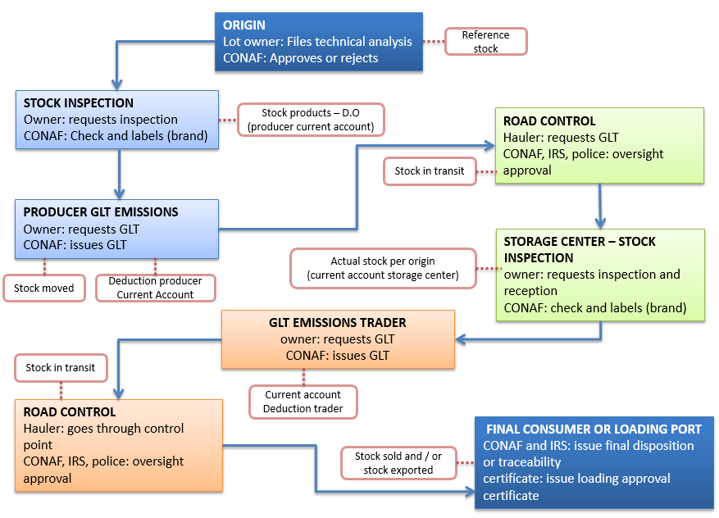

The chart describes the full process of transport or transit for Native Forest products with their respective control mechanisms, such as the Technical Analysis (or Management Plan), stock verification, Free Transit Forms (referred to as GLT in diagram), and checkpoints.

Annex 2: Single Export Document - *Documento Único de Salida – Aceptación a Trámite- DUS–AT (Sample)*

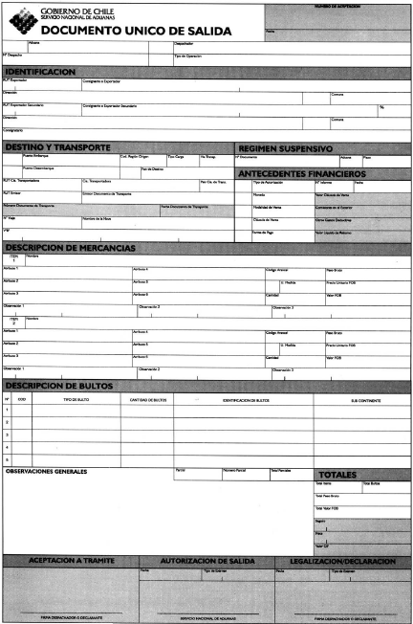

Annex 3: Free Transit Guide- *guías de libre tránsito (Sample)*

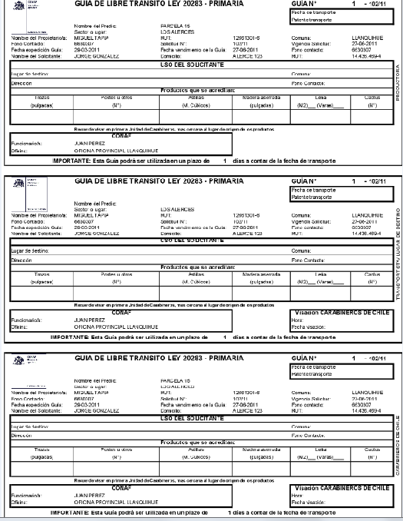

1. CONAF, 2018. Native Vegetation Resources Cadastre, July 2018 update.
2. Law No. 20.283 of 2008
3. Supreme Decree No. 68 of 2009 of the Ministry of Agriculture
4. INFOR-Instituto Forestal Chile 2015
5. INFOR Forest Statistics
6. Law No. 18.362 of 1984
7. Law No. 19.253 establishes in its Articles 13 et seq.
8. Supreme Decree No. 490 of 1976 and No. 43 of 1990 respectively
9. Does not include plantations established on land not preferentially suited to forestry eg agricultural land.
10. Land preferentially suitable for forestry is defined in Decree Law No. 701 of 1974.
11. Decree 4.363/1931
12. Article 32 et. seq., Decree 93 / 2008 and Article 58 from the General Regulations of Law No 20.283.
13. Resolution No. 1300 of 2006 from the National Customs Service
14. Articles No. 32 of Supreme Decree No. 93/2008 and No. 58 of Law No. 20.283
15. Such as the name of the shipping agent or exporter, address, municipality, customs post, port of loading, type of cargo, means of transport, code of the region of origin, port of unloading, country of destination, name of the transport company, name of the issuer, name of the ship, number of the voyage, authorizations, goods volume, F.O.B. value, tariff code, product description, gross weight, type and quantity of containers, *inter alia*)
16. Resolution No. 1300 of 2006 from the National Customs Service